***MongoDB Basics***

**1. Database & Collection Setup:**

o Create a new database (e.g., studentDB)

o Create a collection (e.g., students)

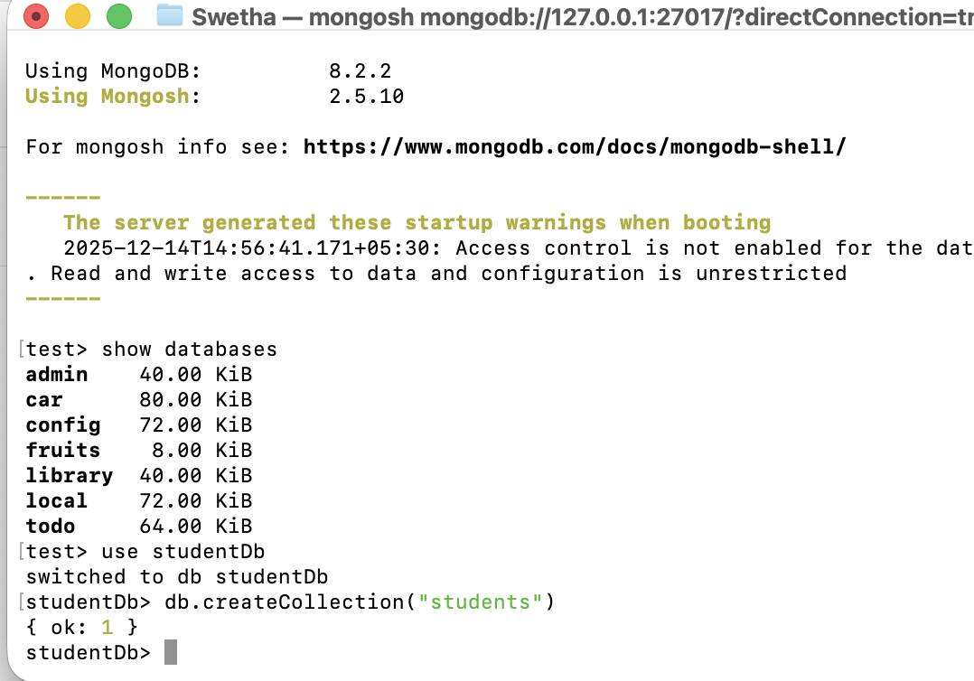

**2. Insert Operations:**

o Insert one document into the students collection.



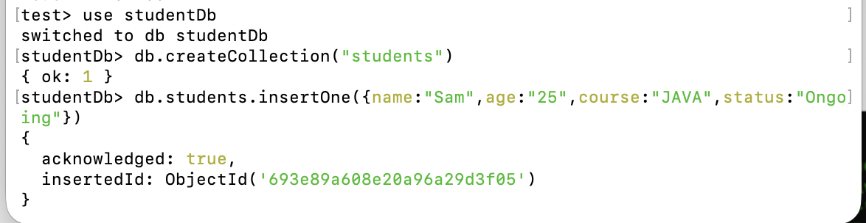

o Insert multiple documents with fields like name, age, course, status.

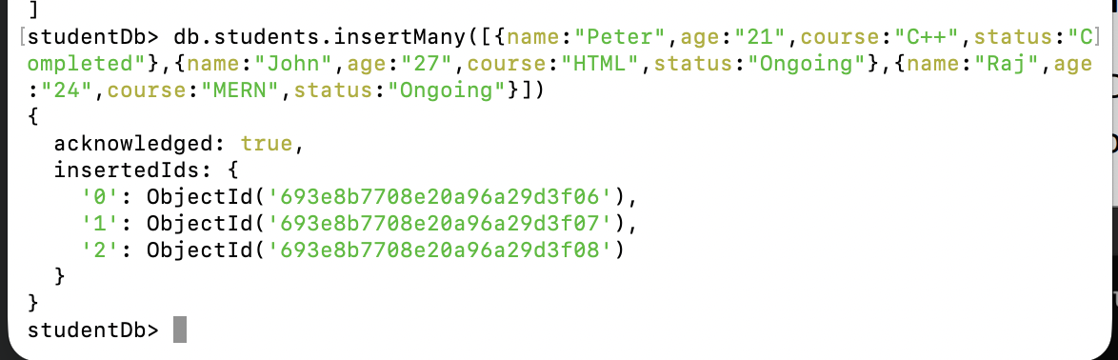

**3. Read Operations:**

o Fetch all documents from the collection.

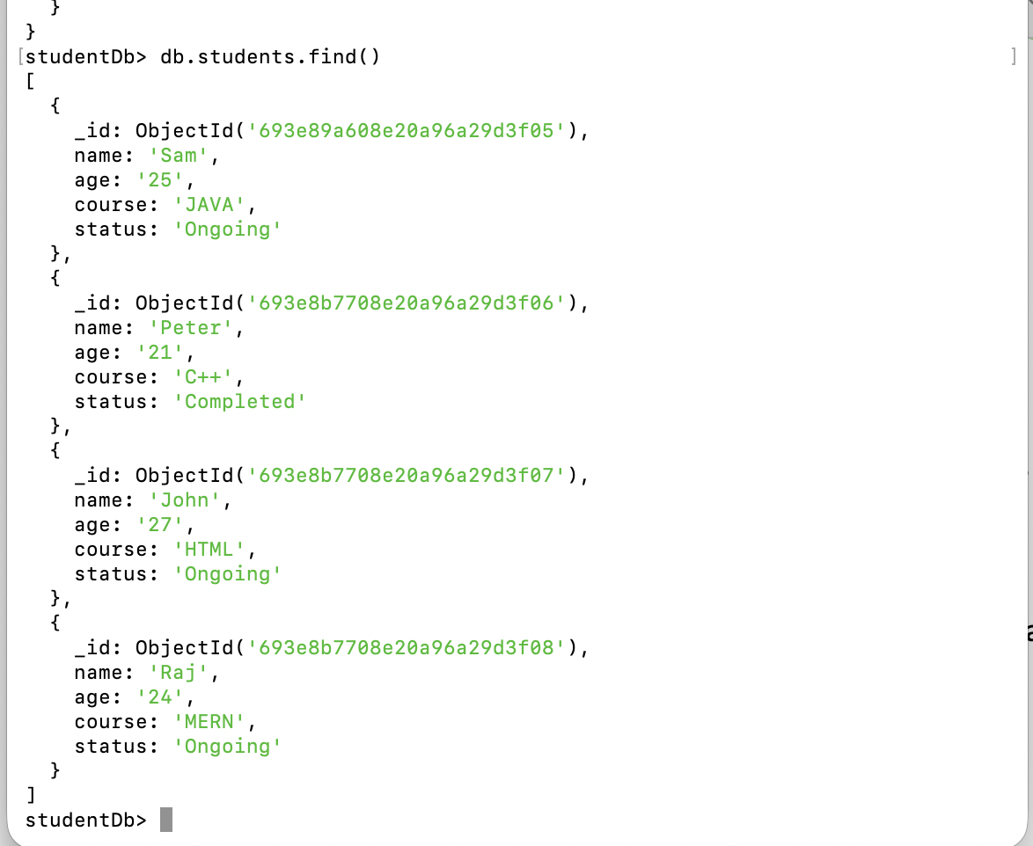

o Use filters to fetch specific data (e.g., students enrolled in “MERN Stack”).

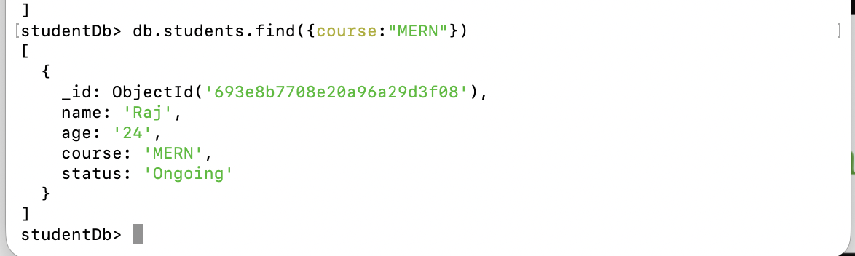

**4. Update Operations:**

o Update a single document (e.g., change the status of a student to completed).

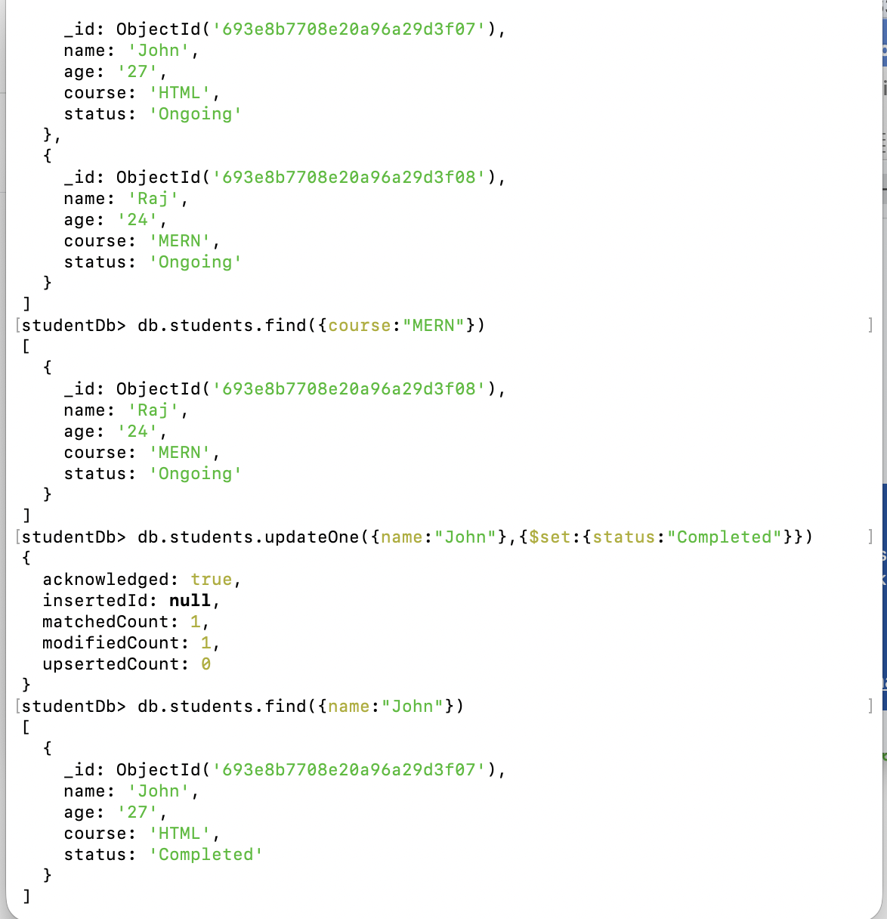



o Update multiple documents at once.

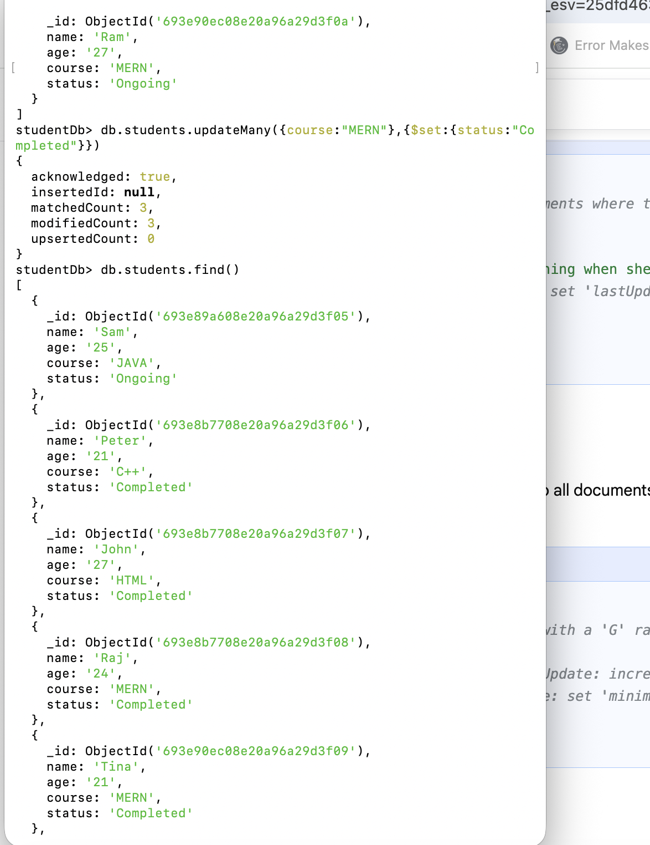



**5. Delete Operations:**

o Delete one document based on a condition.



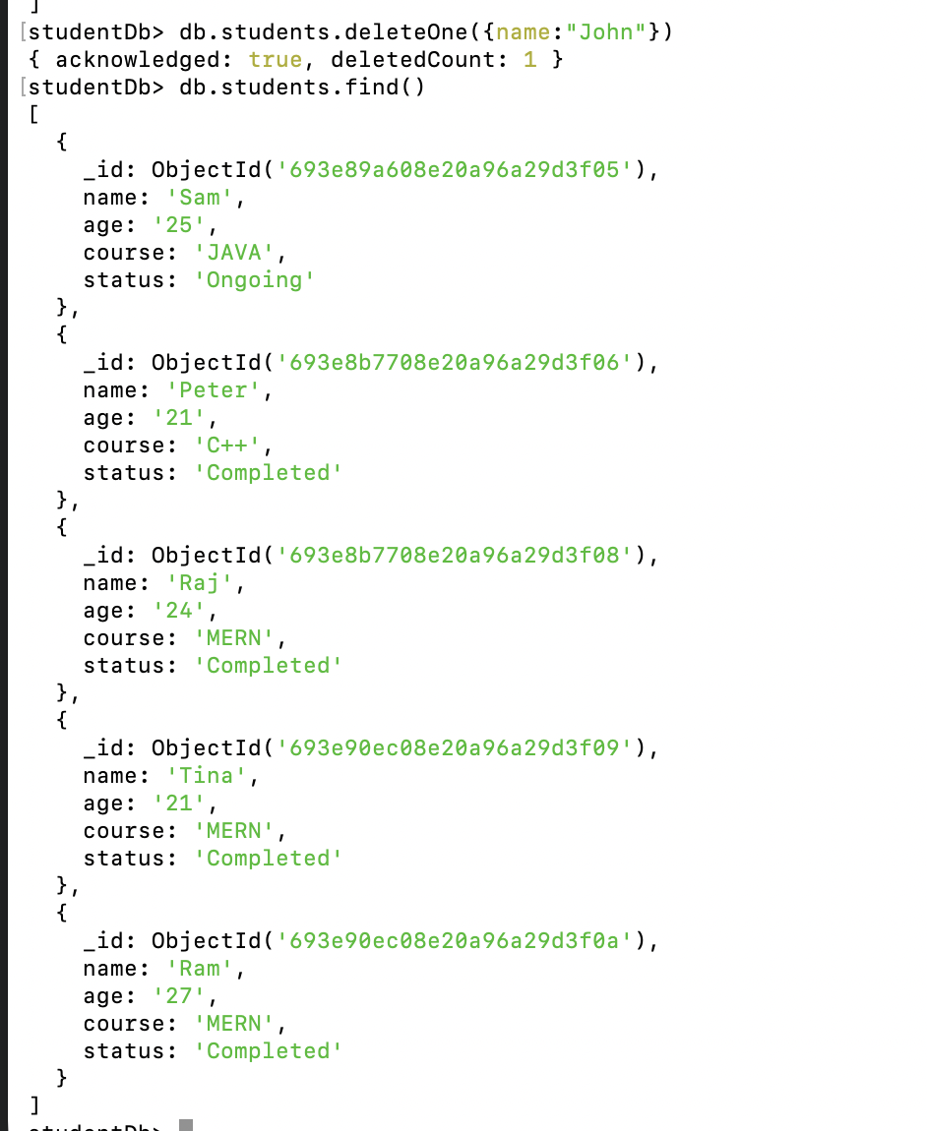

o Delete all documents in the collection (for practice purpose only).

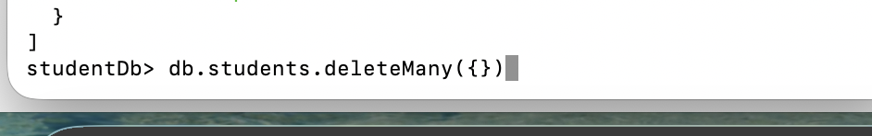

**6. Query Operators:**

o Practice using $gt, $lt, $in, $and, $or, $exists in different queries.

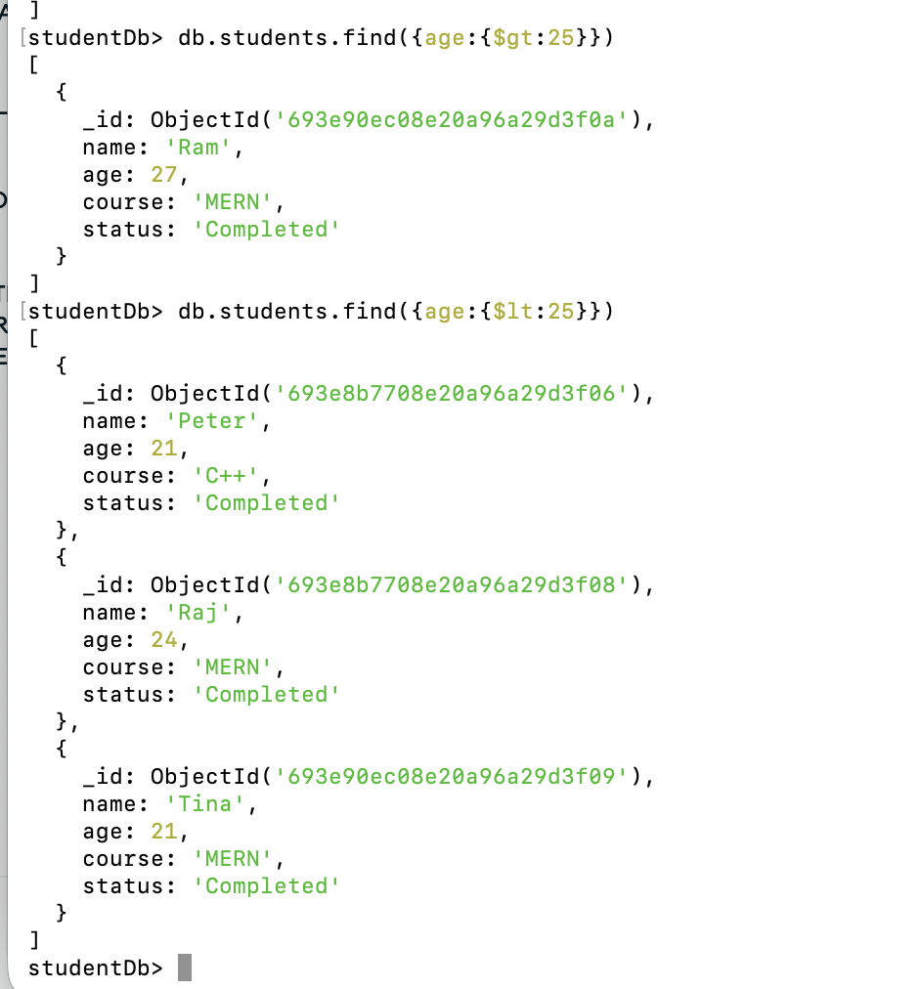

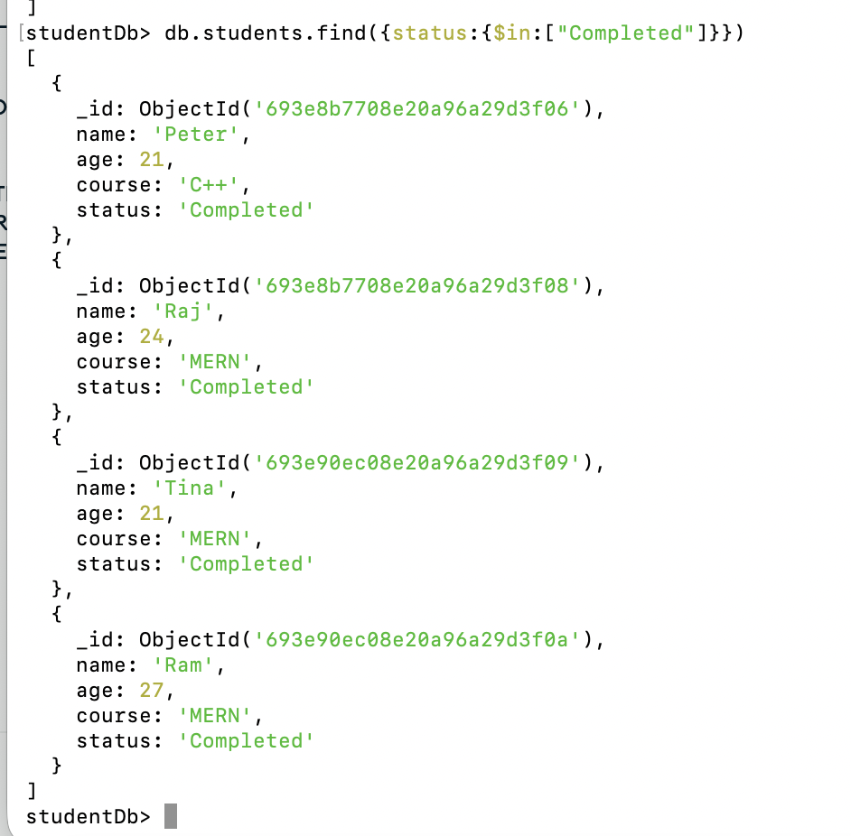

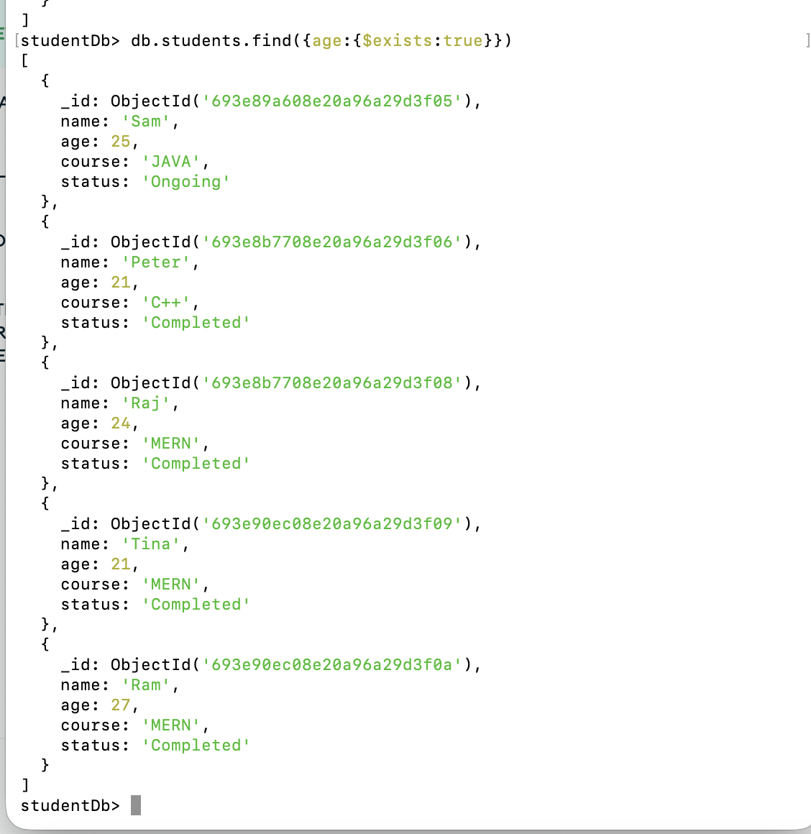

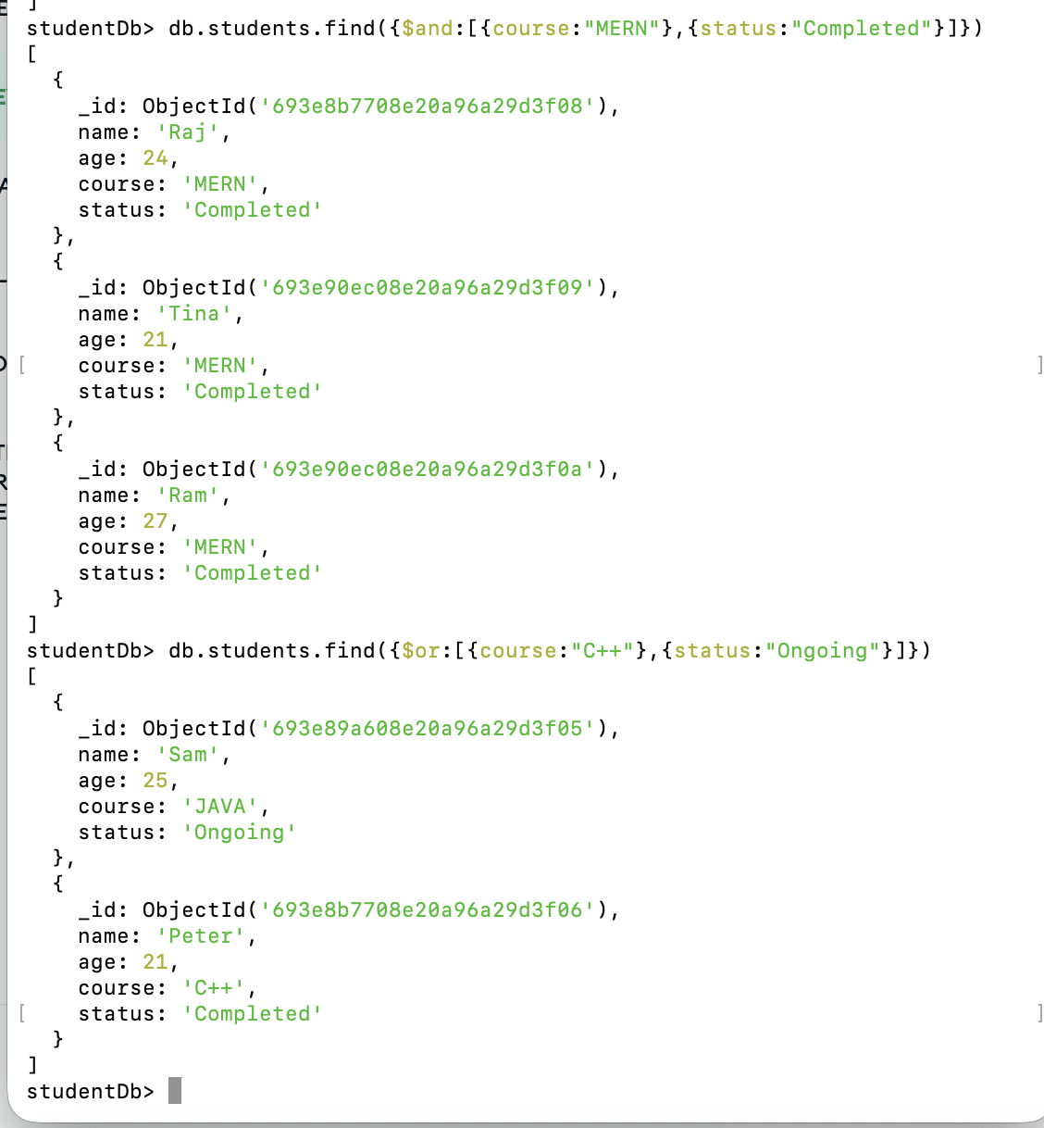

**7. Use Case:**

o Create a small use case like a Library System or E-Commerce product listing and apply insert, update, and search operations.

